Name __________________________________

Cellular Structure and Cellular Processes Crossword Puzzle

Directions: Use the clues below to complete the crossword.
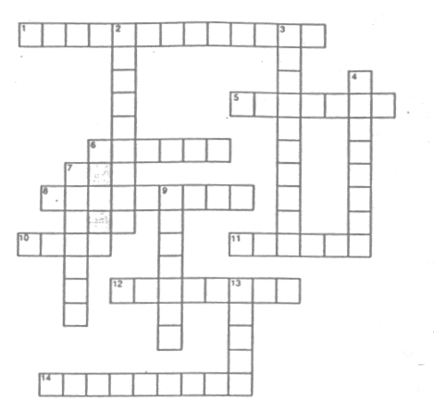

Across

1. An organelle where reactions of cellular respiration occur.
5. A membrane-enclosed organelle found in some protists and in all plants.
6. A short hair-like organelle with the capacity for movement.
8. The site associated with ribosome production within the nucleus.
10. The basic unit of structure and function in living things.
11. A group of cells that are similar and function together.
12. A saclike organelle that contains hydrolytic enzymes.
14. The movement of molecules from a high concentration to a low concentration.

Down

2. A cylindrical organelle in animal cells that is involved in cell division.
3. Specialized structures in the cytoplasm of a cell.
4. The site of protein synthesis in a cell.
7. A dense body within a cell that controls metabolism and reproduction.
9. The diffusion of water across a semi permeable membrane.
13. A body part composed of specialized tissues.

